April 2020

SUNRISE TRANSFORMATION!

Dear Women of Faith,

It is a joy for me to greet you all during this most passionate and holy season of the year. I appreciate so much the reverence and reflective days of Lent that lead us through the final weeks of Jesus life on earth before his sacrificial death by way of crucifixion. Because I live on the other side of Calvary, I confess I approach these days with mixed emotions of sadness, grief, confession, thanksgiving, praise, adoration but mostly ANTICIPATION & CELEBRATION. I can hardly wait for Easter Sunday morning to arrive so I can sing with contagious enthusiasm, ‘Christ the Lord is risen today, Hallelujah!’

As a young girl growing up in the Salvation Army I remember waking up early on Easter Sunday morning still amidst the darkness, yet heading out to church to participate in a march of witness through the streets of my town with the band playing all the familiar Easter melodies. Along the way, the first rays of sunlight would begin to break along the horizon, transforming the uncertain and shadowy scenes into one of clarity and colour. Figures that initially seemed menacing and bleak in the darkness, were found to be something lovely and hopeful in the light. We marched away from the despair of death and darkness into a sunrise service to celebrate Christ’s resurrection victory and the promise of a new day dawning. We would passionately pray that on this Easter Sunday people in our town would come to church and have an encounter with the Risen Jesus.

Can you wonder why I would rather watch a sunrise than a sunset? There is something magical and glorious when the sun begins to rise and you are aware that this is the beginning of a new day! The light fills every fibre of your being with energy, courage and purpose. As I read the familiar Easter story again, I try to imagine the power and glory of that first Easter sunrise.

Mark 16: 1-2 “When the Sabbath was over, Mary Magdalene,
Mary the mother of James, and Salome bought spices so that they
might go to anoint Jesus’ body. Very early on the first day of the week,
just after sunrise, they were on their way to the tomb.’
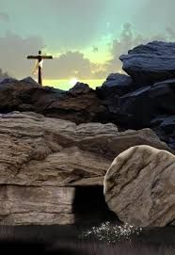
The women went with their spices expecting to find a body lying in the darkness of a tomb. But what they found in the sunrise experience was life transforming and left them with excitement and hearts filled with great joy. Just as the sun had risen, the Son had risen! He is Alive!

The devil thought he had won. Jesus had died on the cross. His limp, lifeless body had been removed from the cross and laid in a darkened tomb secured, sealed and guarded by Roman soldiers. Yet, darkness, death, and the grave could not hold back the Son. He had the authority to lay down his life, and he has the authority to take it up again. The Light of the world could not be extinguished. Hallelujah!

As we celebrate Easter 2020 I am fully confident in the Resurrection of Jesus. I believe every person, regardless of age or background, no matter how dark their circumstances or deeds, when encountering and embracing the Living Light, finds themselves transformed both inside and out! They experience salvation, strength, hope, and Resurrection power! They are filled with a glorious and inexpressible light and joy! Hallelujah!

May your Easter be spectacular and glorious as that first Easter sunrise morning and may you find sacred moments when you can bask in the light of God’s love. I pray also that the light that dwells in you will reflect boldly and brightly into the lives of your family, friends, and communities, so that others may experience the transformation of the Son-rise for themselves.

Easter Blessings,
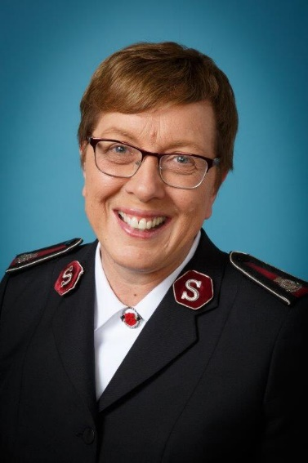
Rosalie
Commissioner Rosalie Peddle
World President of Women's Ministries

OFFICE OF
THE WORLD PRESIDENT
OF WOMEN’S MINISTRIES

